Matthew McColm
Robert Ogilvie
Kindergarten

AbEd Lesson Plan Contest – Canoe building

Science – Big Ideas

Plants and animals have observable features
Humans interact with matter every day through familiar materials
Daily and seasonal changes affect all living things

Content

Basic needs of plants
Adaptations of local plants
Local First Peoples uses of plants and animals
Properties of familiar materials
Seasonal changes

Socials – Big Idea

Our communities are diverse and made of individuals who have a lot in common

Content
People, places, and events in the locals community, and in local First Peoples communities
Process

Generally -- The class has been taking a thematic approach to trees this term – creating a sight word tree, tree based art, fiction and non-fiction books featuring trees, specific science lessons around trees (discussion of oxygen and carbon dioxide leading into discussions of gas and various states of matter).

Specifically
Day 1 -- We began this series of lessons with a general non-fiction book about canoes in Canada. For this introduction, we were paying particular attention to the size, shape, uses, history, and methods (modern and traditional indigenous) of construction. Class discussions and references to previous Socials unit on Canada made.

Day 2 – Reading and discussing Jason’s New Canoe is followed by class discussion on form and method of dugout canoe. Teacher model how to form plasticine into a cylinder/’log’ and use popsicle stick as an axe to cut pieces out of the middle and to shape the outside. STEM challenge issues to have students make their own dugout canoe that floats.
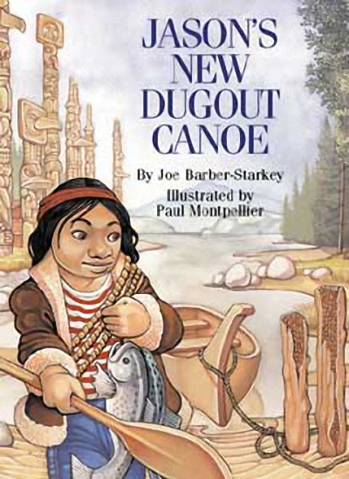
Have a bin with water for students to test their final results. Could also set up bigger bin with rocks, toys, etc in place to mimic a river bed for the student’s to navigate their canoes through.

Extension: while testing kids final craft math concepts of measurement (more/less, heavier, lighter, bigger/smaller, taller/shorter, balance, etc) help the kids to explain the result and/predict what they think will happen when their canoe is tested.

Extension: see which canoe will carry the most weight – marbles, toys figures, etc

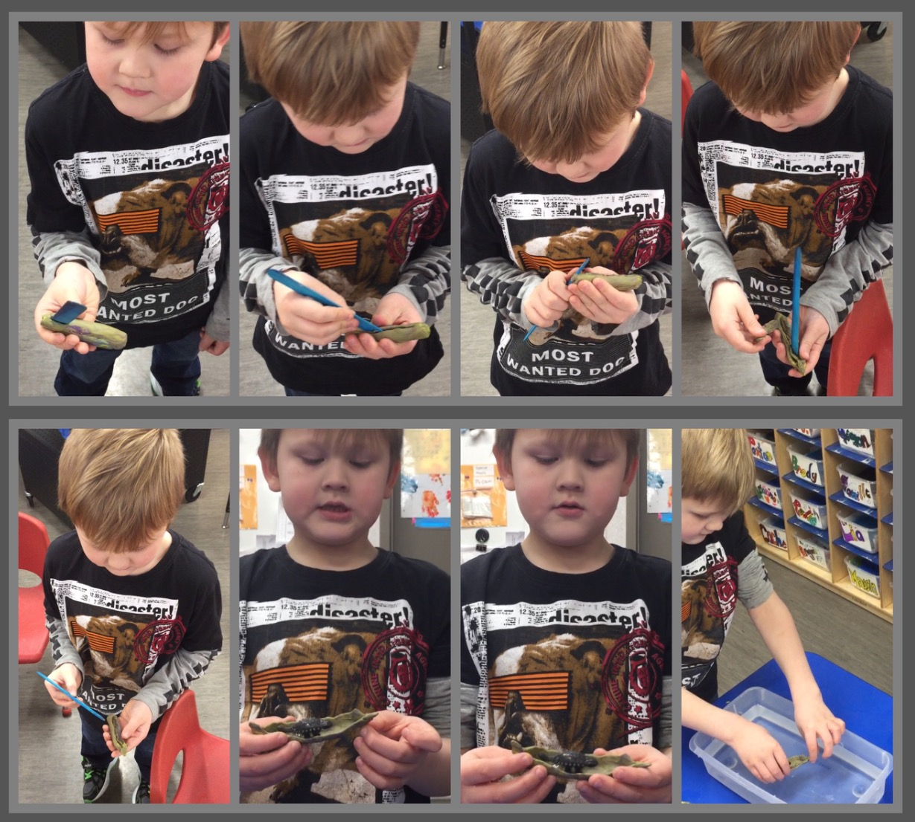

First part of the process; shaping log and making initial cuts

Second part of the process; shaping the outside and digging out the centre

Third part of the process; testing the final product

Day 3 – Revisit concepts already discussed and learnt. Talk about difference between cedar bark and dugout canoes. Brainstorm ways of using plasticine to mimic bark. Wrapping it around a rolling pin while flattening it allows the kids the ability to ‘cut’ and peel the ‘bark’ off the ‘tree’. Once flattened they can shape it.

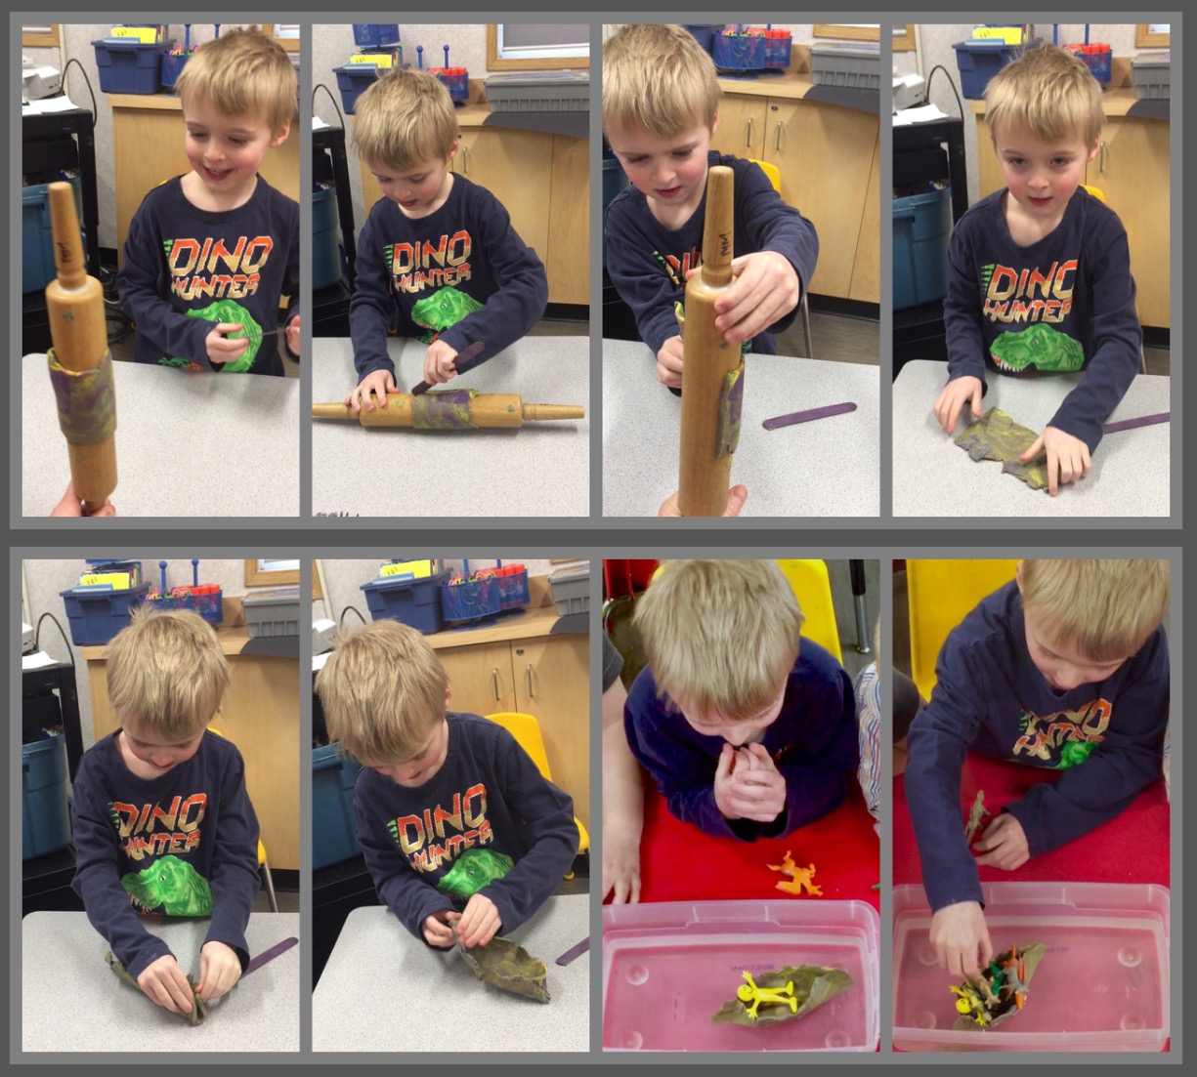

Making the birch bark canoe.

Testing the canoe; a classroom affair.

The same extensions that were used for the dugout canoe can be used here with the addition of comparing and contrasting the results of the two different methods.

