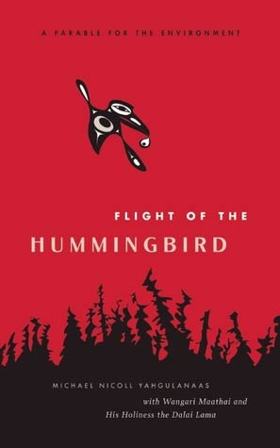
Title: Flight of the Hummingbird
Author: Michael Yahoulangaas, Wangari Maathai, & Dalai Lama XIV
Genre: Picture Book, Fiction, Parable
Cultural Connection: You can make a difference, Protecting the Earth

Plot Summary
Hummingbirds have long been a symbol of wisdom and courage. In this charming story, a hummingbird makes a valiant effort to put out a raging fire that threatens her forest home -- trip after trip, her beak is filled each time with just a drop of water. Her efforts show her woodland companions that doing something -- anything -- is better than doing nothing at all. The hummingbird parable, which originates with the Quechuan people of South America, has become a talisman for environmentalists and activists worldwide committed to making meaningful change. This retelling, enlivened by Michael Nicoll Yahgulanaas' fabulous Haida-manga illustrations, is suitable for all ages of would-be activists. Although environmental responsibility often seems like an overwhelming task, "The Flight of the Hummingbird" shows how easy it is to start and how great the effect could be if everyone just did what they could.
Learning Intentions
In this lesson, we are learning:
- That reading a book can change our thinking.
- To think about the message in the story.
- To use the message in a book to think about our own life.

Materials Required
One copy of Flight of the Hummingbird
Youtube Flight of the Hummingbird:
One copy of the graphic Making a Difference – Adrienne Gear

Before Reading
- Brainstorm and web what the students know about ‘hummingbirds’
- Students discuss their ideas with a partner
- Read title and show the cover of the book
- Predict what the book might be about
- Have students turn to a partner and justify their predictions with the sentence stem: I think this story will be about _____ because_____

During Reading
- Pause at points in the story…to discuss what students are thinking now
- Use frame to talk to a partner “Now, I am thinking________because__________”
- Repeat for chunks 2 and 3

After Reading
- Discuss the following questions:
  - What did the character in this story do to make a difference?
  - How did this story change your thinking?
  - What could you do to make a difference in your world?
- Pair-Share: Discuss questions
- Share to larger group
- Individually complete graphic “Making a Difference”

Extension – Art
Look carefully at the pictures of the hummingbirds, their shape, the important body parts, the colors etc.
Use the SMART coaching card to prompt the students for more detail
Have students sketch an outline of a hummingbird using pencil
Using paint or pastel create beautiful feathers
