Self-Assessment: Critical Thinking January 17, 2017

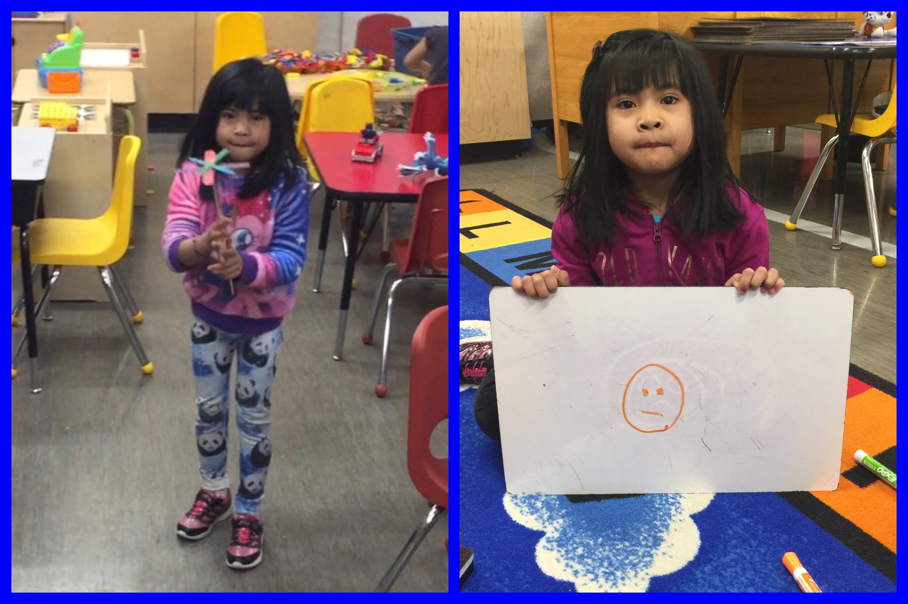

Here you can see Eliana holding the helicopter she made as part of a STEM challenge centre. When I showed her this picture I asked her what problem she was trying to solve while she was making her helicopter. She said she was trying to make a helicopter the flew better and better. She said she kept changing her design to figure out how to do this but she wasn’t satisfied with her final result. When I asked her how well she thought she’d done in solving her helicopter’s problem she chose the orange marker (when we’ve modeled and practiced self-assessment in class the green smiling face = good, the orange straight smile = middle, and the red sad face = can do better) and drew a middle smile on our self-assessment response board. When I asked her why she chose the orange she explained that since her helicopter didn’t fly as good as she wanted she didn’t think she’d tried her best yet.

A video of this conversation will be posted to Elaina’s portfolio as will this self-assessment artifact.

