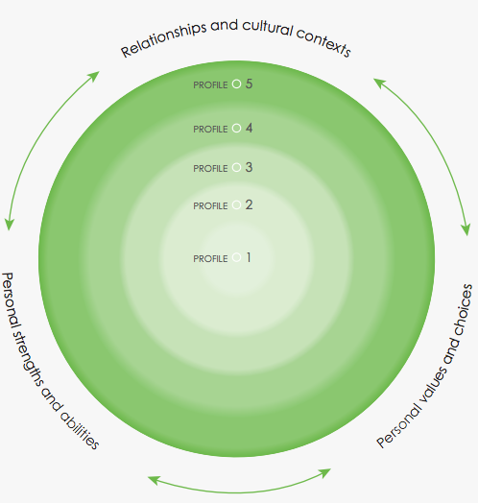
POSITIVE PERSONAL & CULTURAL COMPETENCY

I can tell you about myself.
I can tell you about my family.

POSITIVE PERSONAL & CULTURAL COMPETENCY

I can tell you what is important to me.

POSITIVE PERSONAL & CULTURAL COMPETENCY

I can tell you about a group I belong to.

